**Project Design Phase-II**

**Data Flow Diagram & User Stories**

|  |  |
| --- | --- |
| Date | 03 October 2022 |
| Team ID | PNT2022TMIDxxxxxx |
| Project Name | Project - xxx |
| Maximum Marks | 4 Marks |

**Data Flow Diagrams:**

A Data Flow Diagram (DFD) is a traditional visual representation of the information flows within a system. A neat and clear DFD can depict the right amount of the system requirement graphically. It shows how data enters and leaves the system, what changes the information, and where data is stored.

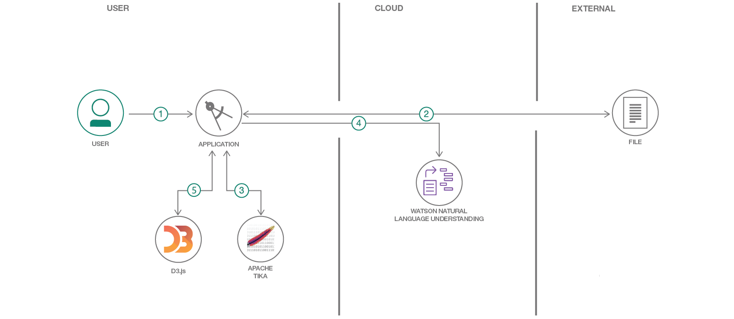

**DATA FLOW DIAGRAM:**

INITIALIZATON

DATABASE OF PRESCRIBED MEDICINES AND THE TIME AND DOSAGE INFORMATION GIVEN INTO THE SYSTEM

TIME TO TAKE MEDICINE?

**NO**

**YES**

NOTIFIES USER WITH A BUZZER OR BLINK

MEDICINE TAKEN?

**NO**

**YES**

**User Stories**

| **User Type** | **Functional Requirement (Epic)** | **User Story Number** | **User Story / Task** | **Acceptance criteria** | **Priority** | **Release** |
| --- | --- | --- | --- | --- | --- | --- |
| Customer(disabled  Person) | Smart medicine app | USN-1 | As a user, I can register for the application by entering my email, password, and confirming my password. | I can access my account / dashboard | High | Sprint-1 |
| Customer(Coma patient) | caretaker | USN-2 | Patient’s medication time and prescription should load in databasefor atleast a week | Patient’s medication time and prescription should load in database list | High | Sprint-1 |
| Customer (Mentally idled person) | Caretaker | USN-3 | Person’s should take medicine regularly and their activity should be monitored. | Patient needs to take medicine on time | Low | Sprint-2 |
| Customer(Alzheimer  Patient) | Smart medicine app | USN-4 | Patient needs to take medicine on time by voice command | Medicine on time by voice command | Medium | Sprint-1 |
| Customer(Senior citizen) | Smart medicine app | USN-5 | As a user, I can log into the application by entering email & password | Taking medicines on time | High | Sprint-1 |